**BOOTSTRAP UPDATION IN CITRUZ-FRAMEWORK**

**IMPORTANT NOTES:**

* Always copy latest bootstrap files into your framework (basic strater kit folder) like below and not the other way round, becasue Citruz Framework has many other inclusions like html5 boiler plate,fontawesome iocns, other extra files like .htaccess,favicon,robots etc..which are not available in bootstrap.
* Never skip any of the steps below, all are important.
* If you leave any step it may lead to compiler and other errors
* Every time when you are updating the less files either it be in citruz.less, variables.less or mixins.less and also when you are copying the each less files please run your less compiler (winless or any other compiler)
* It should run successfully, Check whether when using the latest Less files all the css components and JS components are working and even your custom components are working fine in the kitchen sink template.
* This way you can easily catch if any error happens.
* If you are going to run the compiler finally, you will never be able to find where the error happened. It will be very difficult to debug.
* Then you may need to revert back and start from the beginning.
* If there are any changes in the name or location of the files from the latest bootstrap w.r.t old bootstrap it must be updated in htmls, less and other places where it is needed
* Check Check whether when using new seperate js and full bootstrap.js and bootstrap.min.js,all the js components are working fine in kitchen sink template.
* Check whether new fonts and icons working fine in kitchen sink template is working fine

**PREPARATORY FACE**

1. Keep all your current citruzframework files ready and accessible.
2. Take a backup of all the above mentioned current files in Github and as well as in local repository, so that if there are any issues we can easily revert back.

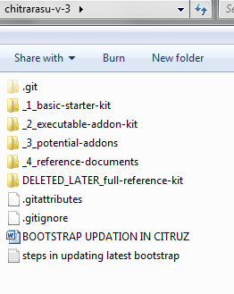

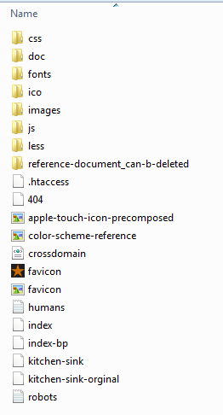

**DOWNLOADING LATEST BOOTSTRAP SOURCE FILE FROM GITHUB**

1. Go to <http://getbootstrap.com/>
2. Never download from here because some files may not be available here as in Github project zip file.
3. In <http://getbootstrap.com/> scroll down and click **View the Github Project**

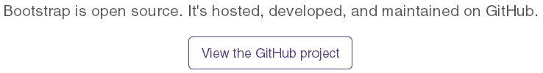

1. Or directly go to <https://github.com/twbs/bootstrap>
2. Click “download Zip” on the extreme bottom right.
3. You will get “bootstrap-master.zip”
4. Create a new folder named “bootrtrap-x.x.x” where x.x.x is nothing but the version of the bootstrap. So now the current folder name is “bootstrap-3.1.1”
5. Unzip the same and place it inside your citruzframework ,here: ! CitruzFramework\_development-kit\_required Assets\Base Assets\Bootstrap\bootstrap-x.x.x.

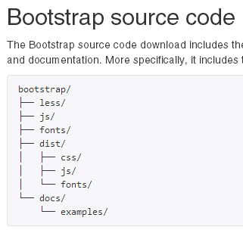

1. Please keep the original zip file intact without deleting for later reference.

**DOWNLOADING LATEST BOOTSTRAP COMPILED MINIFIED FILE FROM GETBOOTSTRAP.COM:**

1. Now go to <http://getbootstrap.com/>
2. Click **“Getting Started”** link and go to “download section” in that page and in that click the link **“Download Bootstrap”** which is nothing but the “Compiled and minified CSS, JavaScript, and fonts. With No docs or original source files are included.”

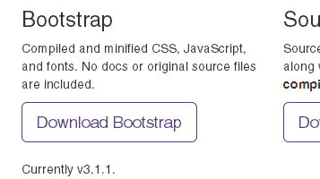

1. Once that is clicked that would download “bootstrap-x.x.x-dist” file (where x.x.x is bootstrap version number right now it is 3.1.1), which is nothing but the Compiled and minified CSS, JavaScript, and fonts. With No docs or original source files are included. Unlike the above source files we downloaded from Github in Step 7.
2. Now extract the bootstrap-x.x.x-dist and place it inside your citruzframework ,here: ! CitruzFramework\_development-kit\_required Assets\Base Assets\Bootstrap\bootstrap-x.x.x

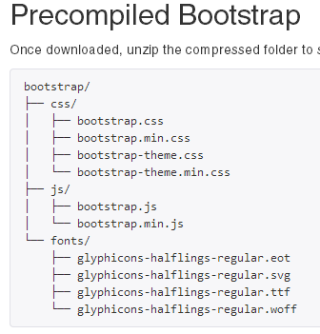

1. Please keep the original zip file intact without deleting for later reference.

**COPYING LATEST BOOTSTRAP FILES INTO “bootstrap” FOLDER IN CITRUZFRAMEWORK:**

1. No copy all the less files from “bootstrap-master\bootstrap-master\less”
2. Even the ones inside folders like “mixins” by copying the whole “mixins” folder, as these files are imported inside mixins.less
3. You can just leave non less files like “.csscomb” and “.csslintrc” which are Janson and CSSLINTRC files. Which are generated by less compiler I believe and we don’t need that in Citruzframework.
4. Delete all the files at “! CitruzFramework\chitrarasu-v-3\_1_basic-starter-kit\less\bootstrap” in Citruzframework.
5. Paste all the files inside your Citruzframework at “! CitruzFramework\chitrarasu-v-3\_1_basic-starter-kit\less\bootstrap”

**UPDATING CITRUZ.LESS USING BOOTSTRAP.LESS: (VERY IMPORTANT)**

1. Copy the “bootstrap.less” from “! CitruzFramework\chitrarasu-v-3\_1_basic-starter-kit\less\bootstrap” and paste it inside “! CitruzFramework\chitrarasu-v-3\_1_basic-starter-kit\less\citruz”
2. Now rename “bootstrap.less” to “citruz.less”.
3. Now open this “citruz.less” from “! CitruzFramework\chitrarasu-v-3\_1_basic-starter-kit\less\citruz” in sublimetext and in the adjacent window in the same sublime text open the old “citruz.less” from the backup we did in “Step 2”
4. Now slowly copy the information **line by line** from the old “citruz.less” into the new “citruz.less”
5. **See to that you always do it this way, from old to new and not the other way round.**
6. **Be very careful whilst copying that you never delete anything from the new “citruz.less” and also be careful not to change in the order of declaration in the latest file, since there may be some difference between old w.r.t new bootstrap.less in bootstrap.**

**UPDATING VARIABLES-CITRUZ.LESS USING VARIABLES.LESS: (VERY IMPORTANT)**

1. Copy the “variables.less” from “! CitruzFramework\chitrarasu-v-3\_1_basic-starter-kit\less\bootstrap” and paste it inside “! CitruzFramework\chitrarasu-v-3\_1_basic-starter-kit\less\citruz”
2. Now rename “variables.less” to “variables-citruz.less”.
3. Now open this “variables-citruz.less” from “! CitruzFramework\chitrarasu-v-3\_1_basic-starter-kit\less\citruz” in sublimetext and in the adjacent window in the same sublime text open the old “variable-citruz.less” from the backup we did in “Step 2”
4. Now slowly copy the information **line by line** from the old “variables-citruz.less” into the new “variable-citruz.less”
5. **See to that you always do it this way, from old to new and not the other way round.**
6. **Be very careful whilst copying that you never delete anything from the new “varibles-citruz.less” and also be careful not to change in the order of declaration in the latest file, since there may be some difference between old w.r.t new variables.less in bootstrap.**

**UPDATING MIXINS-CITRUZ.LESS USING MIXINS.LESS:**

**I am not sure whether updating mixins is very important, right now the mixins-citruz.less is empty, since I don’t have any content declared inside the same. If nothing is update even whilst you are updating the later releases of bootstrap you can skip this step and have the old mixin-citruz.less itself. So please decide accordingly.**

1. Copy the mixins.less” and the “mixins” folder which contains all the separate mixins files called inside “mixins.less” from “! CitruzFramework\chitrarasu-v-3\_1_basic-starter-kit\less\bootstrap” and paste them inside “! CitruzFramework\chitrarasu-v-3\_1_basic-starter-kit\less\citruz”
2. Now rename “mixins.less” to “mixins -citruz.less” and “mixins-citruz.less” respectively.
3. Now open this “mixins -citruz.less” from “! CitruzFramework\chitrarasu-v-3\_1_basic-starter-kit\less\citruz” in sublimetext and in the adjacent window in the same sublime text open the old “mixins -citruz.less” from the backup we did in “Step 2”
4. Now slowly copy the information **line by line** from the old “mixins -citruz.less” in to the new “mixins -citruz.less”
5. **See to that you always do it this way, from old to new and not the other way round.**
6. **Be very careful whilst copying that you never delete anything from the new “mixins-citruz.less” and also be careful not to change in the order of declaration in the latest file, since there may be some difference between old w.r.t new mixins.less in bootstrap.**

**UPDATING JS FILES FROM BOOTSTRAP TO CITRUZFRAMEWORK:**

1. Before downloading any bootstrap js files go to “<http://jquery.com/download/> “ and download latest Jquery file production version. I think that is the minimized compressed version.
2. Save that above file in Citruz Framework at folder “! CitruzFramework\chitrarasu-v-3\_1_basic-starter-kit\js”
3. **Whatever may be the name of the of the above jquery file please rename it to Jquery.js as that is the name we are using in all our html files to link jquery .**

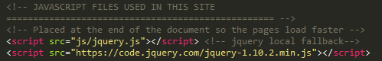

1. Copy each js file from bootstrap saved in assets at “! CitruzFramework\_development-kit\_required Assets\Base Assets\Bootstrap\bootstrap-master-3.1.1\bootstrap-master\js” to your citruzframework at “! CitruzFramework\chitrarasu-v-3\_1_basic-starter-kit\js”
2. Leave the unwanted files and folders like .jscsrc,.jshintrc and tests folder respectively.
3. Now copy the “bootstrap.js” and “bootstrap.min.js” files from “! CitruzFramework\_development-kit\_required Assets\Base Assets\Bootstrap\Bootstrap 3.1.1\bootstrap-3.1.1-dist\bootstrap-3.1.1-dist\js”
4. Place them inside “! CitruzFramework\chitrarasu-v-3\_1_basic-starter-kit\js”

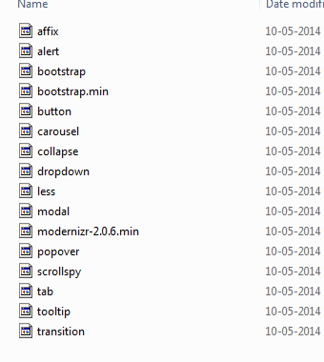

1. This will be used instead of separate js files if all or **even most of the** **js** components are used.
2. If there is are any new js files or if there are any renaming in the files or even if some files are updated in the current Bootstrap JS folder, you need to update the same in the code in the following pages at folder ! CitruzFramework\chitrarasu-v-3\_1_basic-starter-kit: (see screenshot for reference)
   1. Index.html
   2. kitchen-sink.html

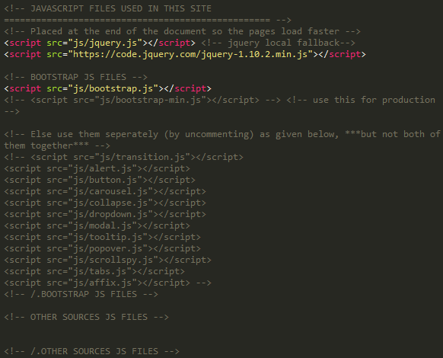

**UPDATING FONT FILES FROM BOOTSTRAP TO CITRUZFRAMEWORK:**

1. Copy all the font files from the following folder in bootstrap “! CitruzFramework\_development-kit\_required Assets\Base Assets\Bootstrap\Bootstrap 3.1.1\bootstrap-master-3.1.1\bootstrap-master\fonts”
2. Paste the above copied files in to the following folder into “! CitruzFramework\chitrarasu-v-3\_1_basic-starter-kit\fonts”**in Citruzframework by deleting the only the files from previous bootstrap and not other files like fontawesome and others.**

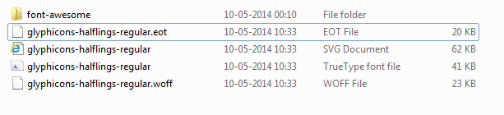

**UPDATING ICO ( FAV ICON AND APPLE TOUCH FILES) FILES FROM BOOTSTRAP TO CITRUZFRAMEWORK:**

**I am not sure whether updating favicon inside the ico folder is need or not, Though right now we are using bootstraps default fav icon , however in future you may change it to some thing related to citruzframe, so if that is the case you skip this step and have the old your own icons as Citruz framework fav icon and apple touch icon itself. So please decide accordingly.**

1. Copy Icon files from Bootstrap from here “! CitruzFramework\_development-kit\_required Assets\Base Assets\Bootstrap\Bootstrap 3.1.1\bootstrap-master-3.1.1\bootstrap-master\docs\assets\ico”
2. Paste the same in the following folder in the Citruzframework in the folder “CitruzFramework\chitrarasu-v-3\_1_basic-starter-kit\ico”
3. If there are any other assets other than what you got from previous Bootstrap please see to that you are not deleting them during this updation.

**CONCLUSION:**

1. Now you are done with Bootstrap updation.
2. Now your citruzframework will be updated with the latest bootstrap files.
3. Hence all the classes and components in bootstrap will work fine.
4. ☺